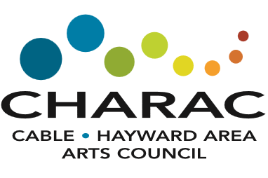 | 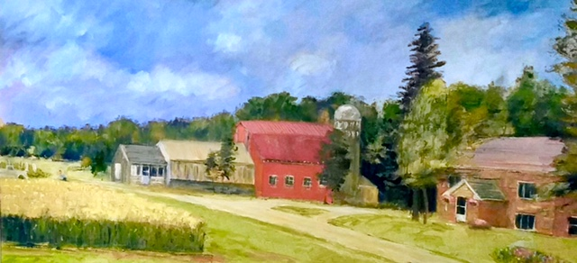

A Toast to Art – At the Farm
June 13, 2019
5:30 – 8:30 pm
Tamarack Farms Winery
Silent Auction Donation Information
Donor Name:
Email:
Phone:
Donation Description/Title:
Value:
Please Email form to Carol Anderson at carolandfigaro@gmail.com by May 15!!

